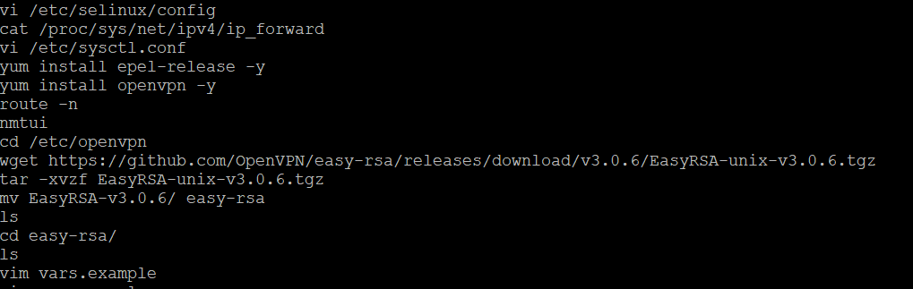

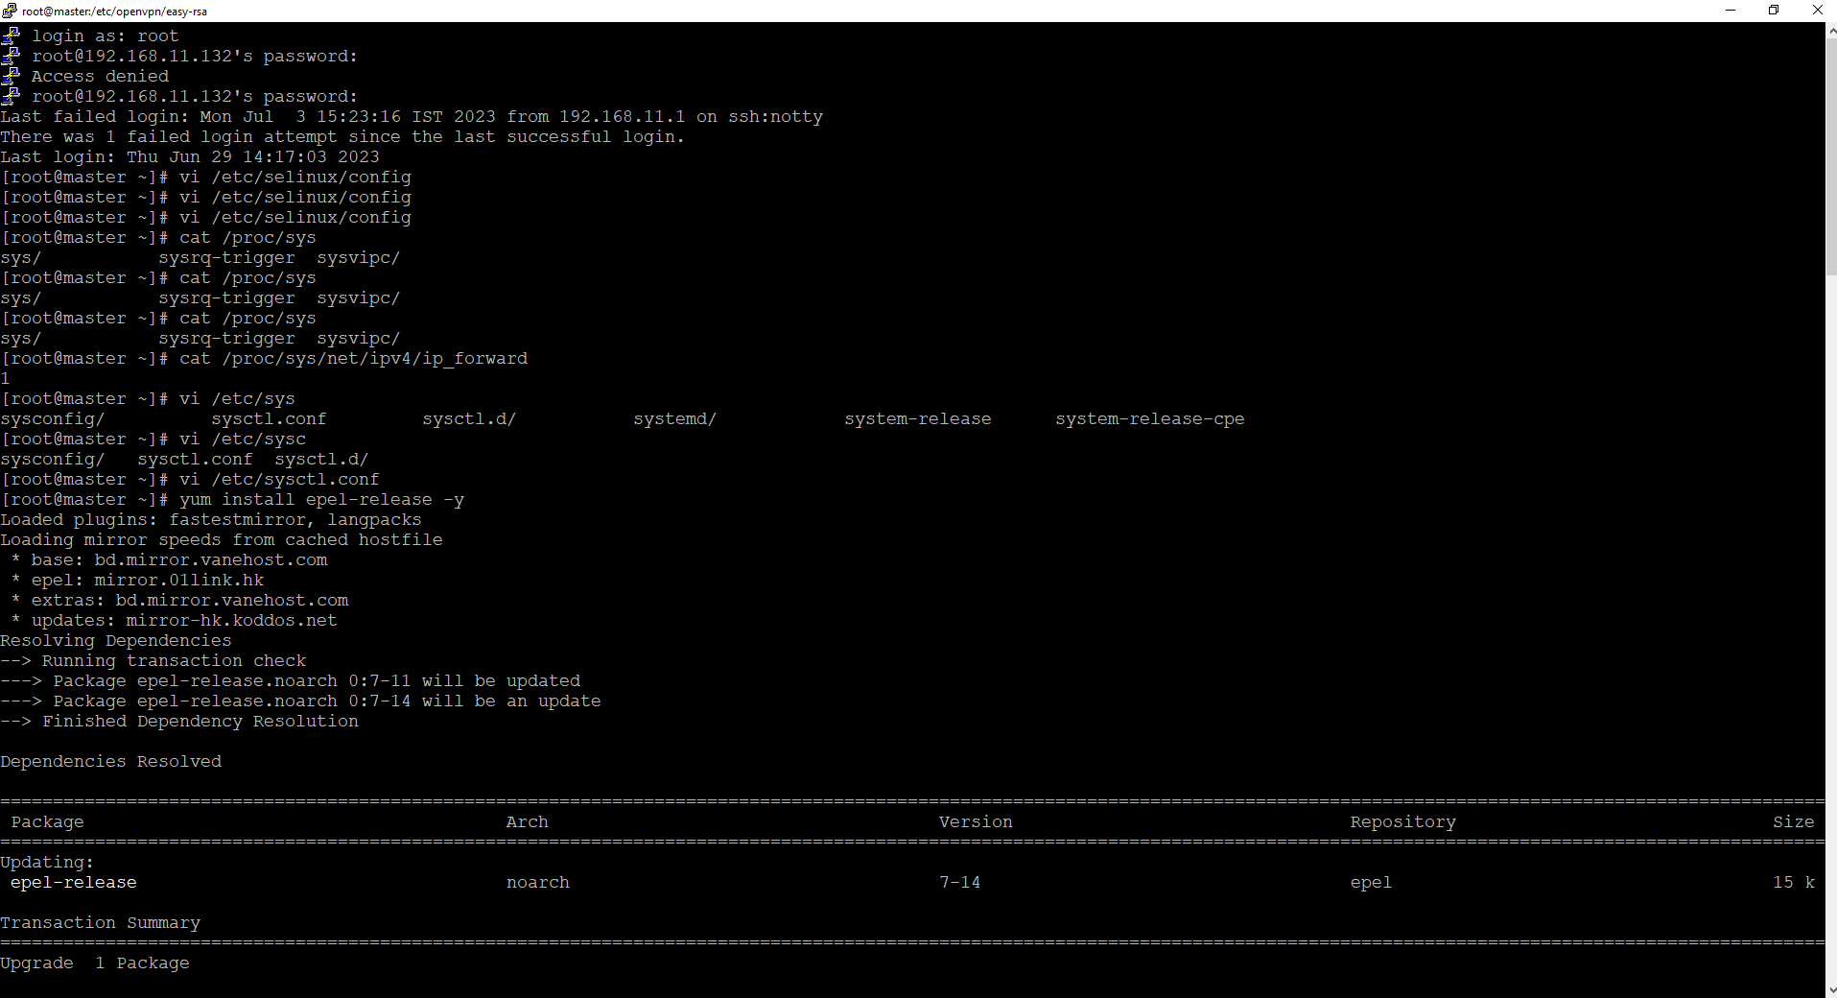

Add cerificate details

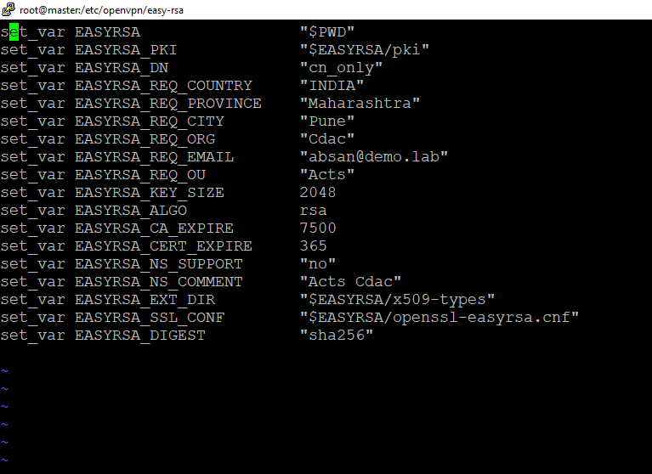

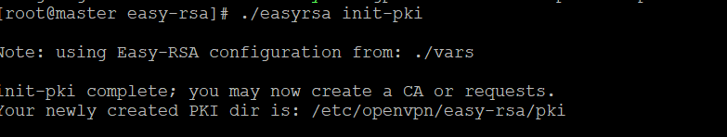

Run Below command and enter the Password and Common Name

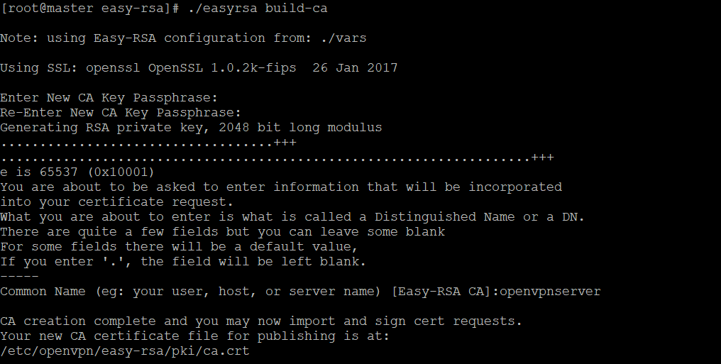

Now Check PVT key and Public key is generate, public key- ca.crt and Pvt key- ca.key



Now generate certificate for server ,give name as demovpn and then Enter while Asking For common Name

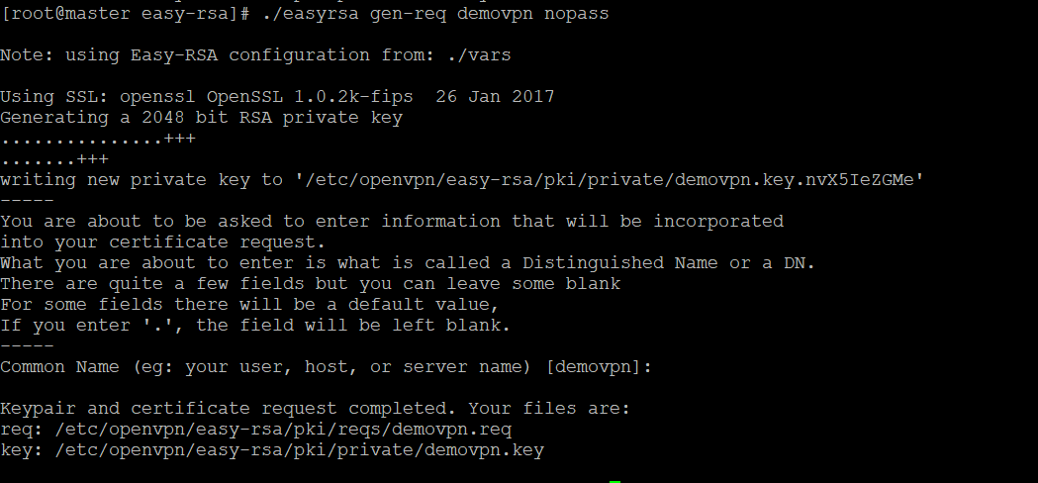

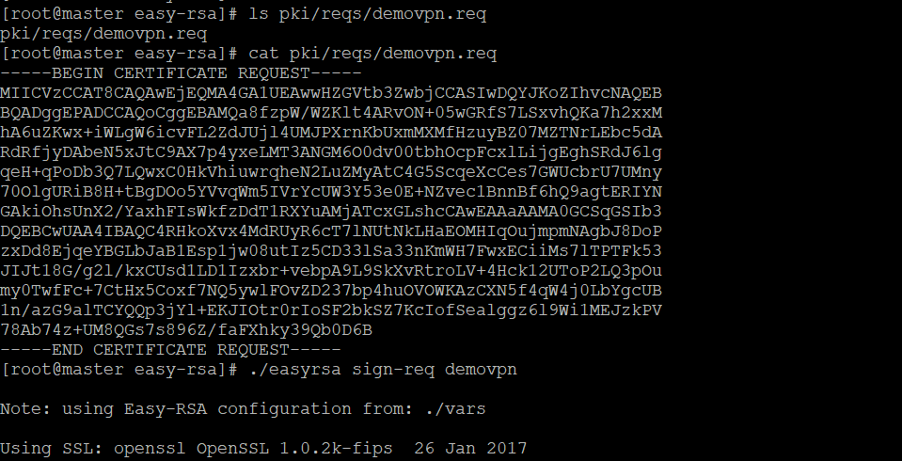

**Sign the Server Key Using CA**

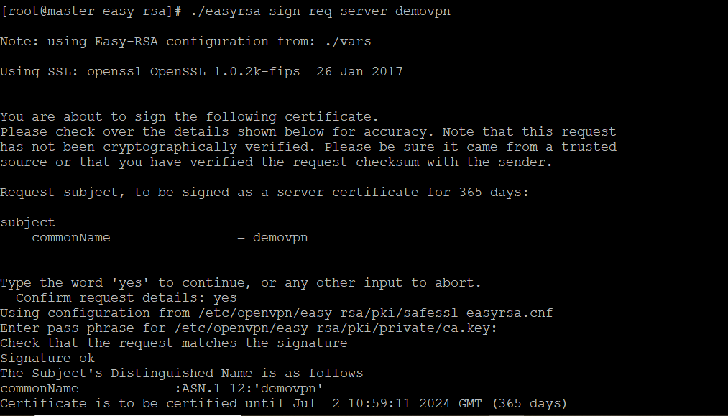

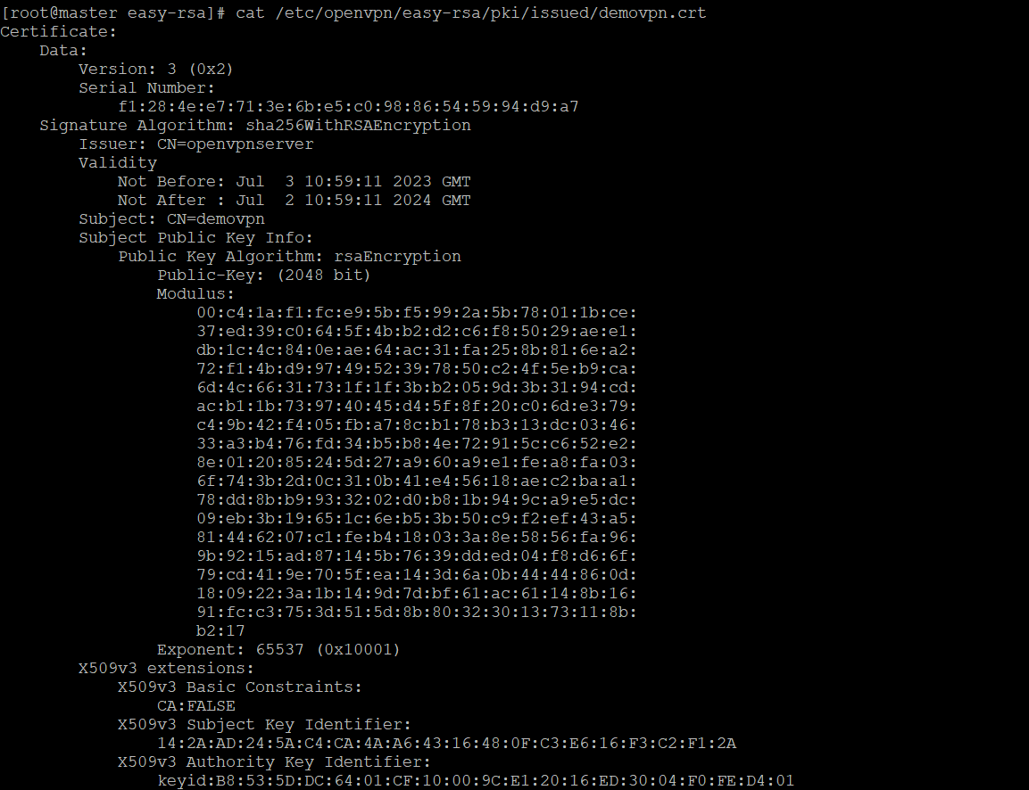

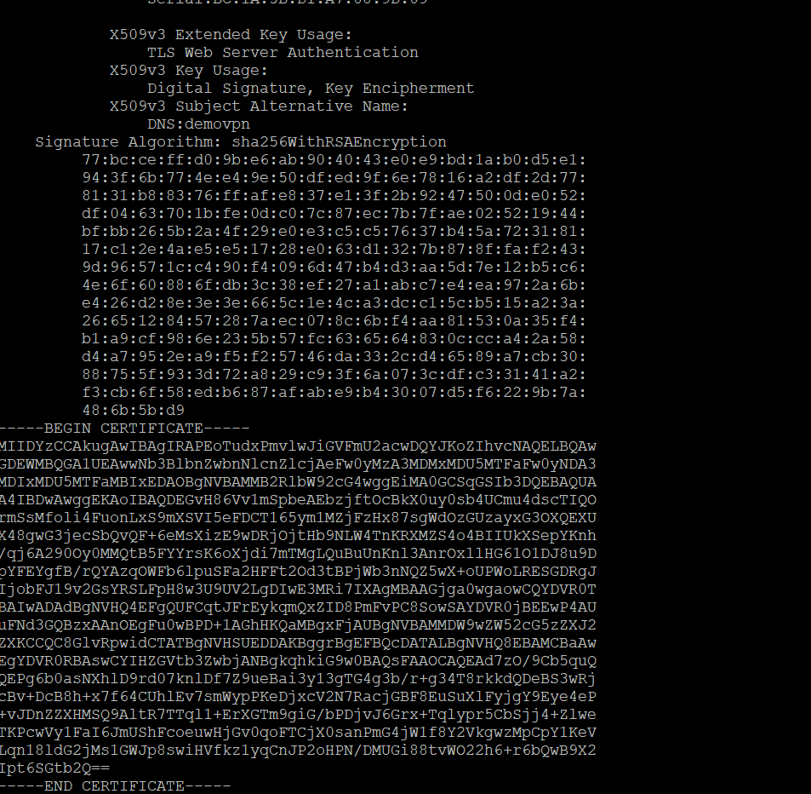

verify the generated certificate file with the following command:



Next, run the following command to generate a strong Diffie-Hellman key to use for the key exchange



After creating all certificate files, copy them to the /etc/openvpn/server/ directory:



run the following command to build the client key file, Enter the Common name as the clients host name

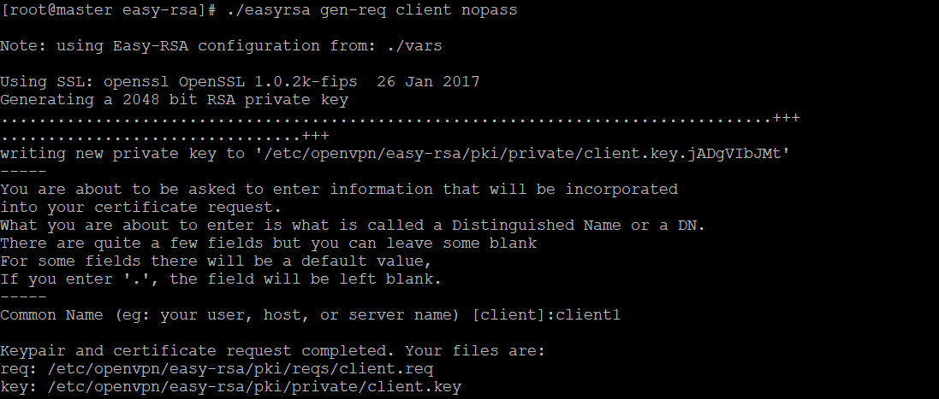

sign the client key using your CA certificate: say yes and enter the password

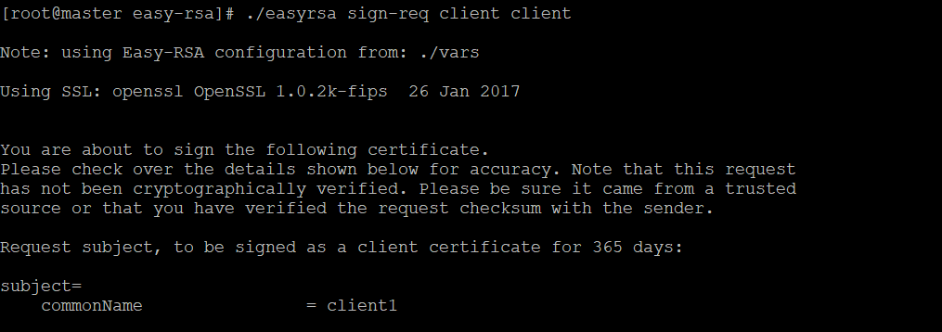

Now Create Certificate For New User Jerry

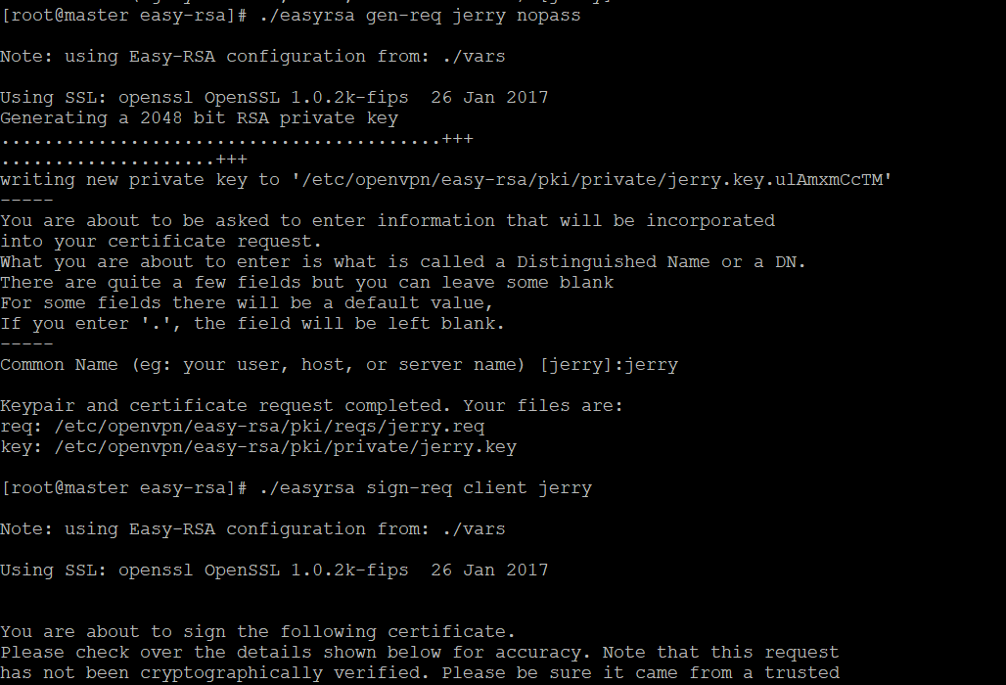

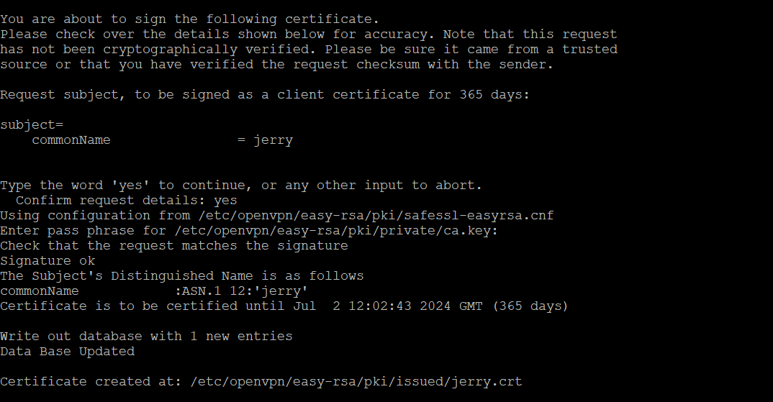

copy all client certificate and key file to the /etc/openvpn/client/ directory:



create a new OpenVPN configuration file inside /etc/openvpn/client/ directory:

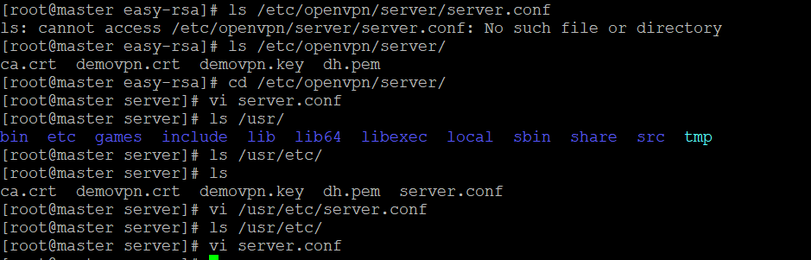

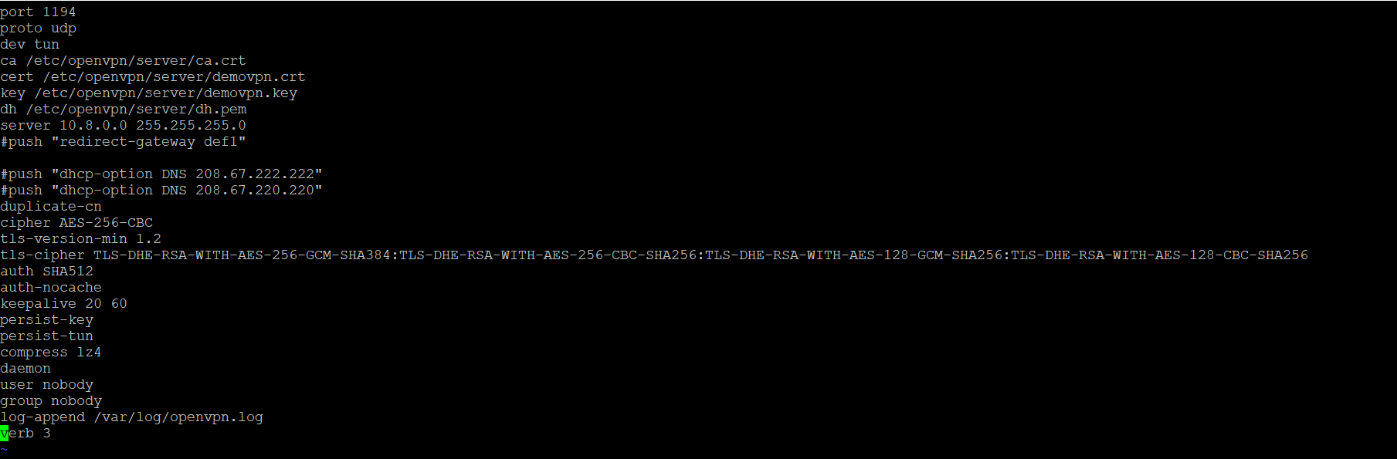

Check the status of openvpn server

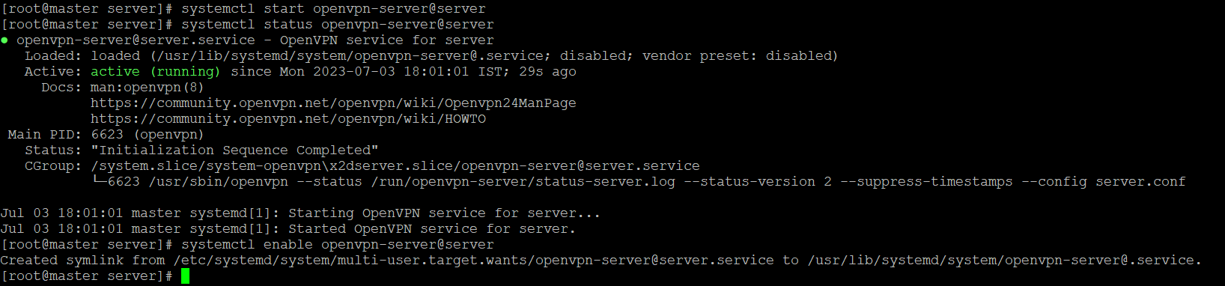

Configure firewall

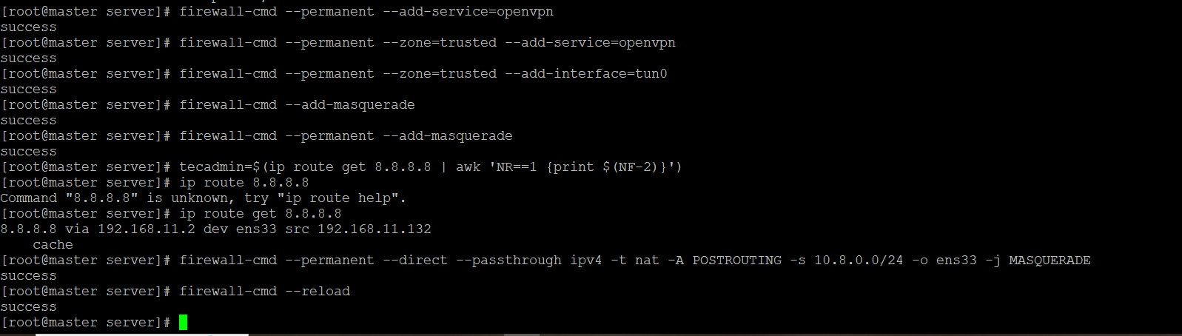

## Generate Client Configuration File

## vi /etc/openvpn/client/client.ovpn

## 

## Install epelrelease and openvpn on linux client

## Yum install epel-release –y

## Yum install openvpn -y

## Check the ip for windows machine

## 

## Create index.html in the inetpub/wwwroot/index.html

## 

Then give manual ip to the linux client machine and activate and deactivate the connection and restart networkmanager

And then try to ping windows ip it should be unreachable and webpage also unreachable.

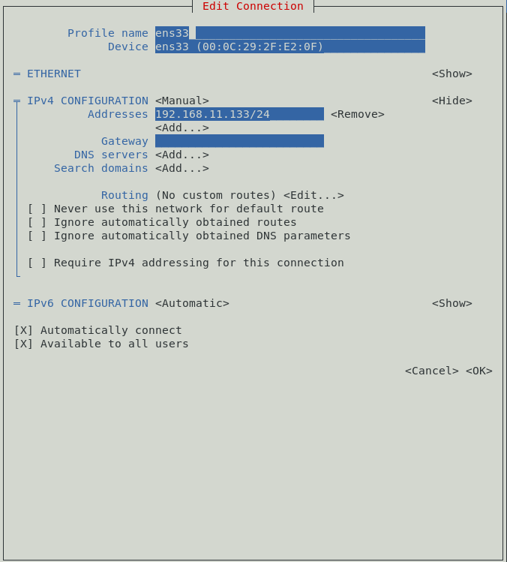

Ifup ens33 ifdown ens33

Systemctl restart NetworkManager

Now try to ping windows ip and access webpage it should be unaccessible.

Give #ip a check for tun0 network adapter then run this command openvpn –config client.ovpn

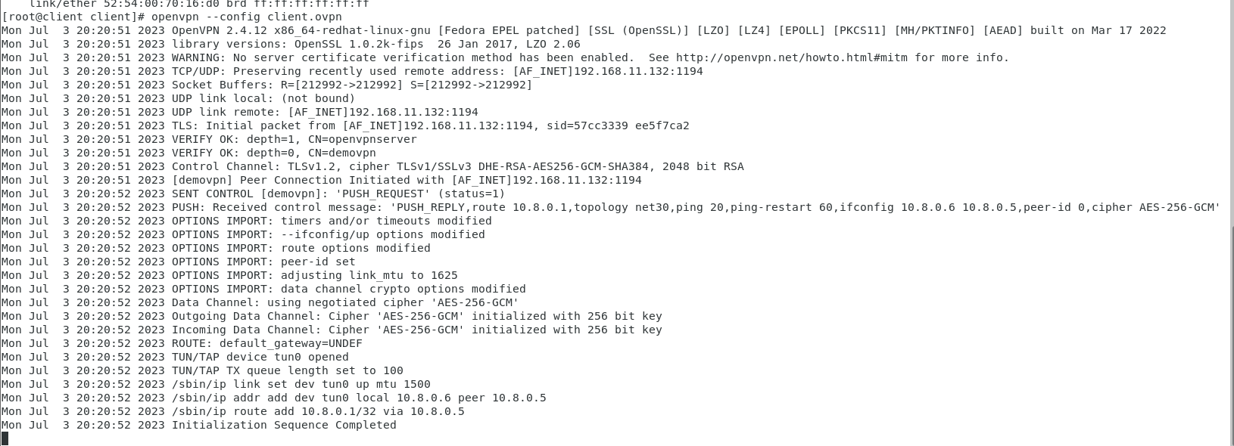

Ctrl +c on client linux and check route –n the windows ip in route table to access web page

For that add this line push route “windows hostonly network ip and subnet mask” and save in /etc/openvpn/server.conf

And restart the openvpn-server@server

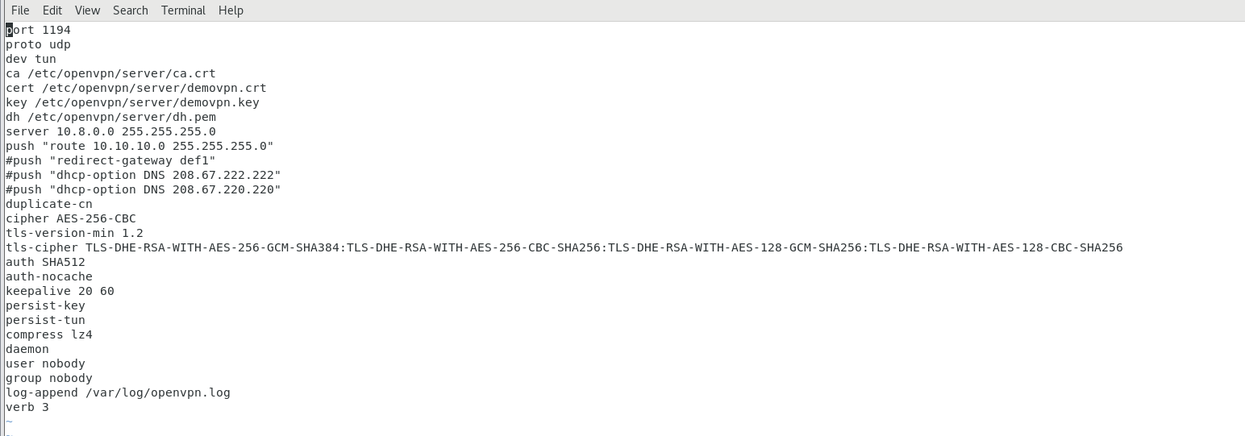

On client linux machine give command for openvpn access

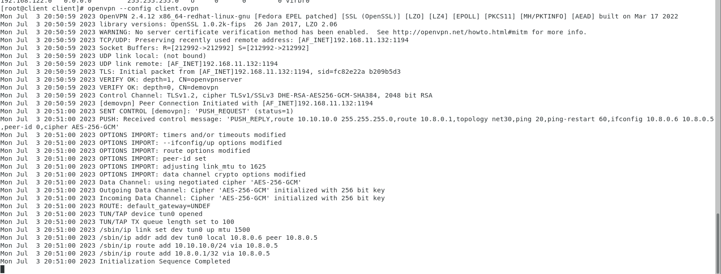

Access the web page on browser

